Summer Preparation for Year 12 Health and Social Care

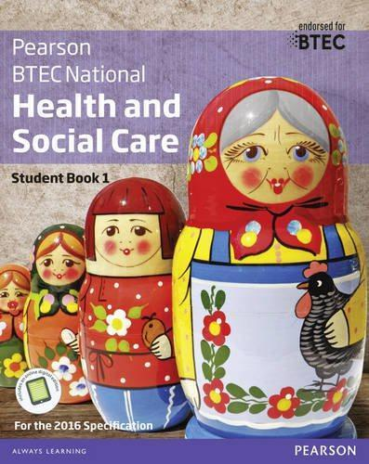
The units that we currently offer are:
Extended Certificate only (below only)
1. Human Lifespan Development.
2. Working in Health and Social Care.
5. Meeting Individual Care and Support Needs.
12. Supporting Individuals with Additional Needs.

Diploma (above and below)

4. Enquiries into Current Research in HSC.
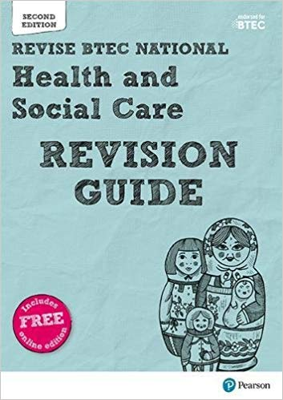
7. Principles of Safe Practice in HSC.
8. Promoting Public Health.
19. Nutritional Health.

*These units are subject to change.*

The textbooks that we use in school are:
- BTEC National Health and Social Care Book 1. (ISBN: 9781292126012)
- BTEC National Health and Social Care Book 2.
- (ISBN: 9781292126029)
- BTEC National HSC Revision (ISBN: 9781292230443)
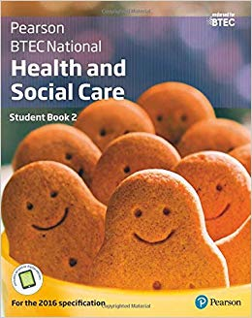
Textbooks are not mandatory but may support you in your private study periods and at home.

If you choose to buy your own, please look around on several websites to save you money!

Health and Social Care is everywhere, so you’ll be able to see aspects of it in all forms of media. Try searching for the following titles and make notes on any videos you watch; try to keep it relevant to the topics taught in Health and Social Care (see above).
- The Toddlers who took on Dementia (DailyMotion)
- 24 hours in A&E / One Born Every Minute (4OD)
- The Restaurant that makes mistakes (4OD)
- Old people’s home for 4 year olds (4OD)
Make any notes from your video observations here:
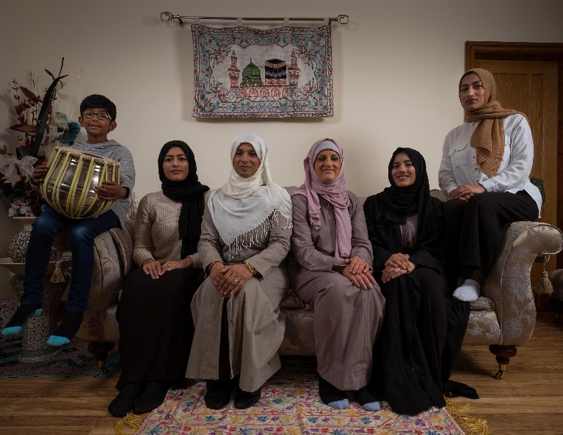
Task:
Watch ‘My Week As a Muslim’(4OD) and answer the questions below.
Why did Katie want to conduct this research? What did she find?

How did Katie have to adapt to Muslim life?

Was it necessary to produce a documentary like this? Explain why.

Are social care services improving people's wellbeing?
The Care Act has not delivered hoped-for change – but there is a way to deliver a better quality of life for older and disabled people - Mon 23 Apr 2018
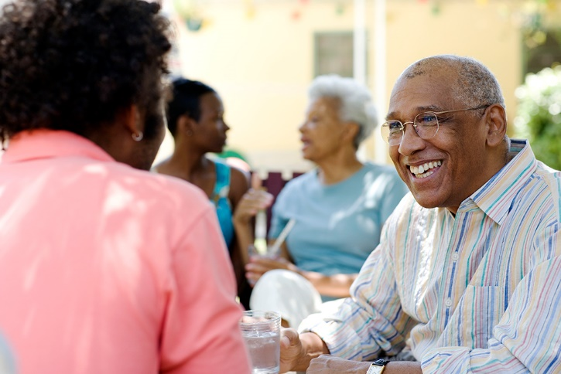
If the 2014 Care Act has one widely known ambition, it is that individuals’ wellbeing should be the over-arching consideration in all that councils do. Social care should focus on what makes the lives of each older or disabled person better. So, if promoting wellbeing is the acid test of the personalisation programme, how are councils doing?
In 2016-17, a new measure was introduced. Councils had been required to survey service users annually. But how people rate their wellbeing is affected by many factors beyond a council’s control, such as the nature and severity of their condition, so NHS Digital devised a sophisticated method to control these factors, creating a measure of what it calls “the impact of adult social care”.
The scale goes from zero (“no better than being dead”) to one (“full quality of life”). The national average score was 0.4. The lowest-scoring council was Kensington and Chelsea in London at 0.29 and the highest Sandwell in the West Midlands at 0.48. It is hardly encouraging that social care is leaving people closer to feeling “no better than being dead” than having a “full quality of life”, with no council getting past the halfway point. But the “postcode lottery” in provision enables us to know more about whether the Care Act is working. If it is, we can expect councils that spend more to be improving well-being most.
Changes to the annual returns councils provide to NHS Digital mean we now know how many people each authority provides ongoing support to during the year and how much in total is spent supporting them. In 2016-17, Southend in Essex supported 3,260 people at home spending £19.1m, an average of £5,800 a person. At the other end of the scale, Wokingham in Berkshire supported 1,240 people at a cost of £24.1m, an average of £19,435 a person, almost four times as much. But Southend achieved a higher wellbeing score (0.41) than Wokingham (0.38). The 10% of highest spending councils averaged £15,930 a person and scored an average 0.4 for wellbeing; the 10% of lowest spenders spent £7,270 per person and averaged 0.39.
The figures we used relate only to those in receipt of long-term support. There are separate returns showing numbers of people getting short term support and the amount spent on them. We excluded those. This significantly reduces any anomalies that might arise from “turnover” of service users. The good news if you live in Wokingham and are eligible for public support is that you will get a far higher level of support than someone in Southend with the same level of need. The bad news is that it won’t make much difference.
These figures resonate powerfully with findings by Ipsos Mori last year. The pollsters studied data from the Health Survey for England and the English Longitudinal Study of Ageing. Researchers found that the extent to which needs were met had little impact on people’s sense of wellbeing. The problem is the conventional understanding of “need”. People are typically asked about difficulties, the routines of daily living and what they can’t do. This creates a narrow focus based on weaknesses. This has two negative consequences for wellbeing: services address deficits in a way that undermines the autonomy and resourcefulness that people treasure, and overlook needs that are more important to the person’s sense of wellbeing, such as social contact.
Given a choice, people may prefer to struggle on meeting their daily living needs and get support to meet the needs that will make their life better.
In 2014 we noted that the legislature, through the Care Act, had created the legal framework for real change. However, we warned that the government’s strategy for implementing the act would undermine its ambitions. Our advice was unheeded. It is no surprise that Jeremy Hunt, now secretary of state for care as well as health, made no mention of the Care Act in his recent overview of what needs to happen in social care. But it can still be done. Government must divest itself of the belief that personal budgets will transform social care. We have set out how that belief is illusory. Eligibility of need must be replaced with affordability of need as the means to control spending. The things that really matter to people must be the foundation of all that happens.
While the system may fall short because of resources, there will be two important changes. First is that what support is provided will be targeted on what really matters to the person. Second, the system will know the true gap between needs and resources. As the Local Government Association noted in its submission to the joint parliamentary committee inquiry into the future of social care, estimates of the funding gap fail to address needs either completely unmet or undermet.
Hunt says he wants a system that addresses the “whole person” and gives them control. Neither can happen under a system where “need” is standardised and rooted in personal deficits. It can only occur if the lived experience of need becomes the foundation of all that happens. Hunt will then have the bonus of what any progressive secretary of state for health and social care needs: knowledge of the true cost of enabling all older and disabled people to have the level of wellbeing right for them.
Outline The Care Act (2014):

What is the post-code lottery?

Summarise the article above:

Women more likely to die after heart attack because doctors see it as a male problem, study finds
Women are being left at risk of repeat heart attacks and early death because doctors see heart disease as a male problem, a new study has shown. Researchers from The University of Leeds and the British Heart Foundation claim women are dying because many are not offered stents to unblock arteries, or prescribed statins, after their first heart attack.
Around 42,000 men and 28,000 women die from coronary heart disease in Britain each year, with most deaths related to an original heart attack. But the new study, which looked at data from more than 180,000 people over 10 years, found three times the expected number of women died in the first year of a heart attack, compared to men. Experts claim women are being denied lifesaving treatment because they are not considered at high risk. “We need to work harder to shift the perception that heart attacks only affect a certain type of person,” said Professor Chris Gale, Professor of Cardiovascular Medicine and Honorary Consultant Cardiologist at the University of Leeds who co-authored the study.
“Typically, when we think of a heart attack patient, we see a middle-aged man who is overweight, has diabetes and smokes. This is not always the case. Heart attacks affect the wider spectrum of the population – including women. “The findings from this study suggest that there are clear and simple ways to improve the outcomes of women who have a heart attack – we must ensure equal provision of evidence-based treatments for women.”
The research found that women were less likely than men to receive the recommended treatments after a heart attack. Women who had a the type of attack where the coronary artery is completely blocked by a blood clot, were 34 per cent less likely than men to receive procedures which clear blocked arteries and restore blood flow to the heart, such as bypass surgery or a stent. They were also 24 per cent less likely to be prescribed statins, which help to prevent a second heart attack, and 16 per cent less likely to recommended aspirin, which helps to prevent blood clots.
Critically, when women did receive all treatments recommended for patients who have suffered a heart attack, the number of women dying decreased dramatically. Previous BHF research has also shown that women are 50 per cent more likely than men to receive the wrong initial diagnosis and are less likely to get a pre-hospital ECG, which is essential for swift diagnosis and treatment.
Professor Jeremy Pearson, Associate Medical Director at the British Heart Foundation, said: “Heart attacks are often seen as a male health issue, but more women die from coronary heart disease than breast cancer in the UK. “The findings from this research are concerning – women are dying because they are not receiving proven treatments to save lives after a heart attack.
“We urgently need to raise awareness of this issue as it’s something that can be easily changed. By simply ensuring more women receive the recommended treatments, we’ll be able to help more families avoid the heartbreak of losing a loved one to heart disease.” Women were less likely than men to receive artery opening surgery or a heart bypass
Researchers worked with the Karolinksa Institutet in Sweden, and the findings are based on Swedish health records between 2003 and 2013. But Sweden has one of the best healthcare systems in the world, so the experts believe the situation could be even worse in Britain. “Sweden is a leader in healthcare, with one of the lowest mortality rates from heart attacks, yet we still see this disparity in treatment and outcomes between men and women,” added Prof Gale.
“In all likelihood, the situation for women in the UK may be worse.” The research was published in the Journal of the American Heart Association.
Why do you think heart attacks are seen as a ‘male’ health problem?

This article highlights a gender inequality within the healthcare system, how would feminists respond to this?

Other research has found that only 39% of women who have cardiac arrest in the street receive CPR compared to 45% of men. This means that men have a higher chance of survival. Why are women less likely to receive CPR?

Who are CQC? Explain their role in Health and Social Care:

Who are NICE? Explain their role in Health and Social Care

Who are Ofsted? Explain their role in Health and Social Care

How do these above professional bodies regulate health and social care professionals?

Discuss ways that health and social care professionals are regulated by professional bodies [8 marks]

Outline Ainsworth's theory of 'types of attachment':

Outline Bowlby’s theory of the effects of separation.

Thinking of PIES and emotional development. What are some of the effects of divorce on emotional development (positive and negative)?

Elizabeth is 48 and lives with her husband Bill who is 50. They have 2 children, Sam who is 4 and Fiona who is 15. Elizabeth and Bill have decided to divorce.
With reference to relevant theories, assess the possible effects of his parents' divorce on Sam’s emotional development [10 marks].

